Get responses tailored to you
Log in to get answers based on saved chats, plus create images and upload files.
Log in
🏕️ Sharjah Camping Sites for Motorhomes, Trailers & RAM Popup Campers
(Remal Caravan Edition 🚐✨)
Sharjah is a hidden gem for campers—offering desert dunes, beaches, and mountain escapes perfect for motorhomes, camping trailers, and RAM popup campers. With the right setup and Remal Caravan branding, your camping experience becomes both premium and adventure-ready.

🚐 Remal Caravan Camping Setup (Motorhomes, Trailers & RAM Popup)
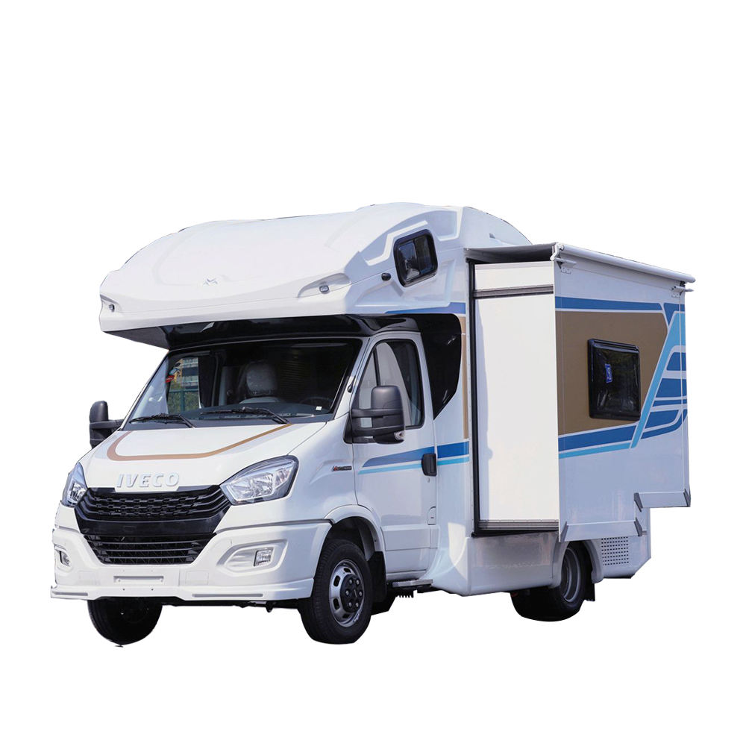
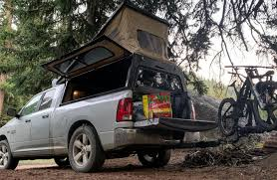
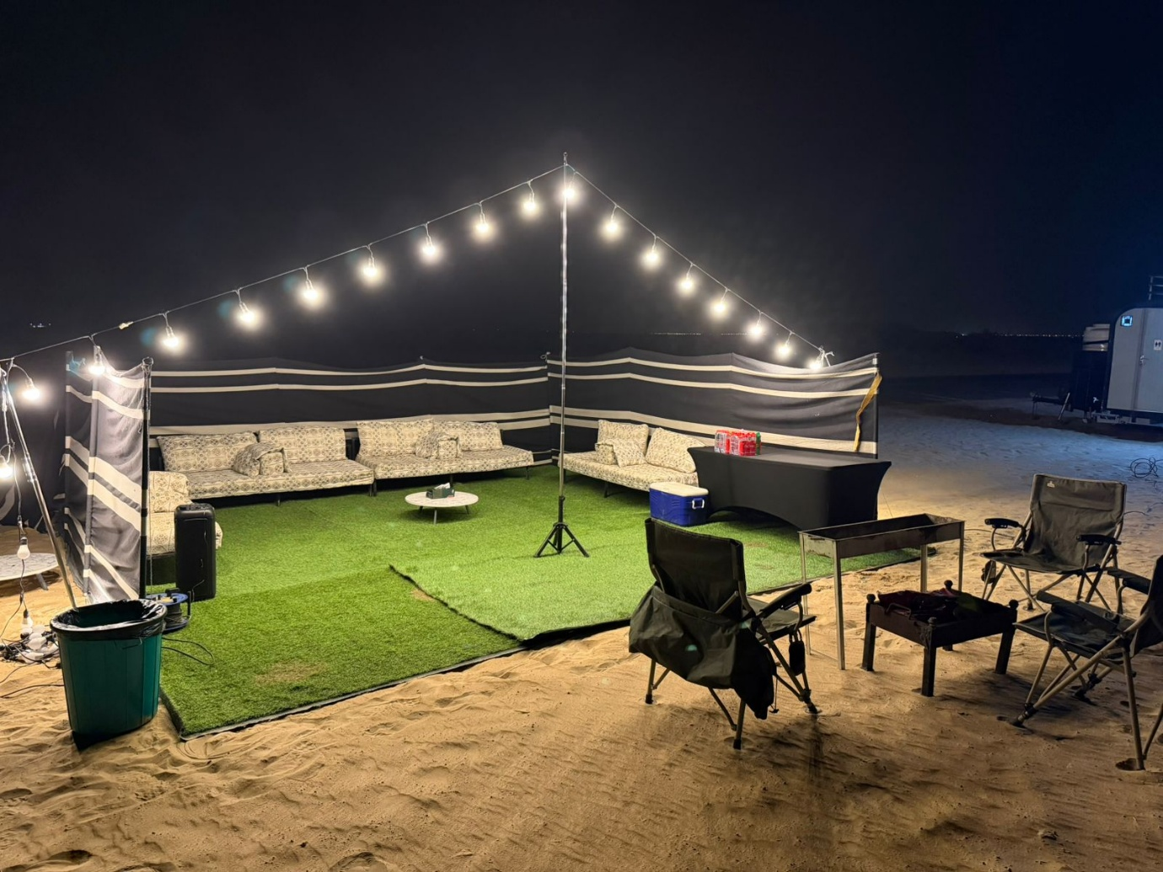
4
🔥 Signature Setup by Remal Caravan:
- Branded Remal Caravan motorhomes & trailers
- RAM popup campers for off-road flexibility
- Outdoor BBQ station 🍖
- Premium chairs, tables & ambient lighting 💡
- Full desert/beach lifestyle setup
Perfect for marketing, rentals, and customer experiences.

🏜️ 1. Al Badayer Desert – Best for Full Setup Camping
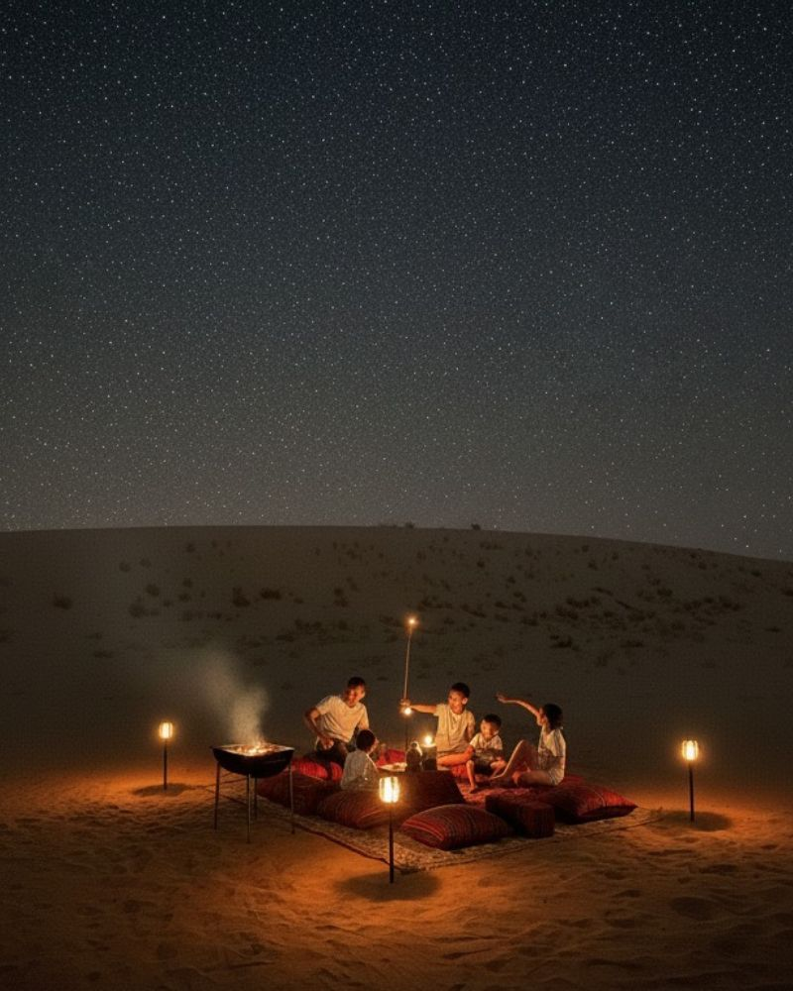
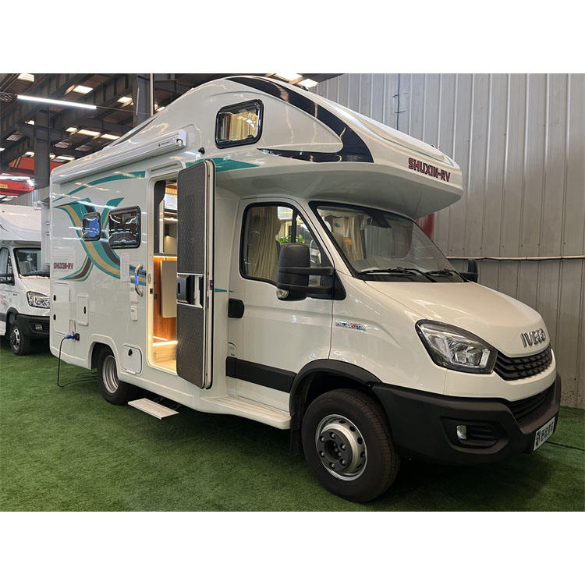
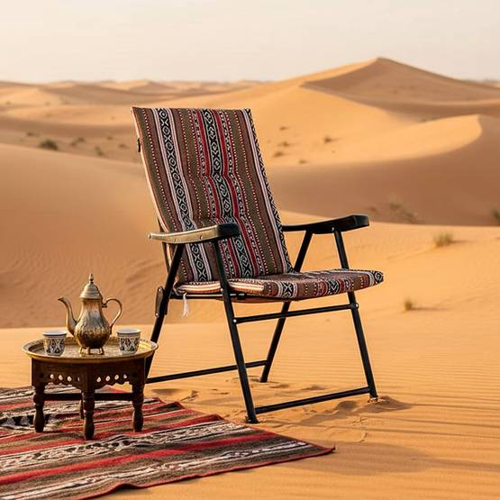
4
At Al Badayer Desert, you can create a full Remal Caravan experience.
Ideal for:
- RAM popup campers 🛻
- Iveco motorhomes 🚐
- Camping trailers
Activities:
- BBQ nights & bonfire 🔥
- Dune bashing
- Group camping setups

🌊 2. Khor Fakkan Beach – Coastal Luxury Camping
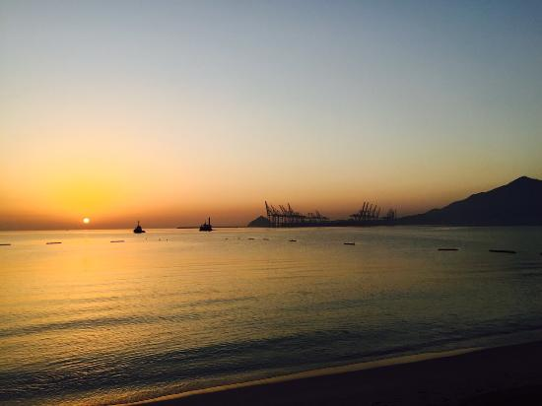
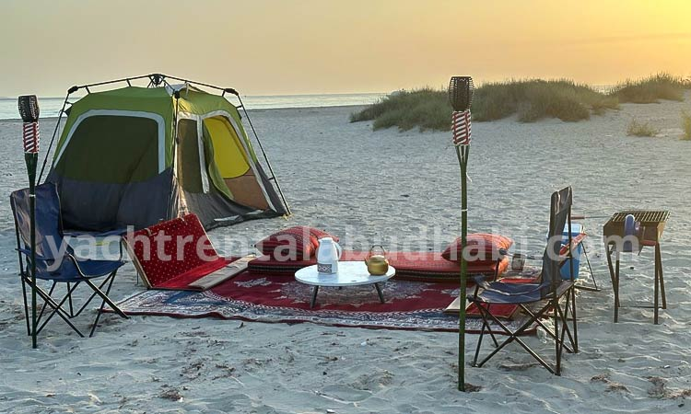
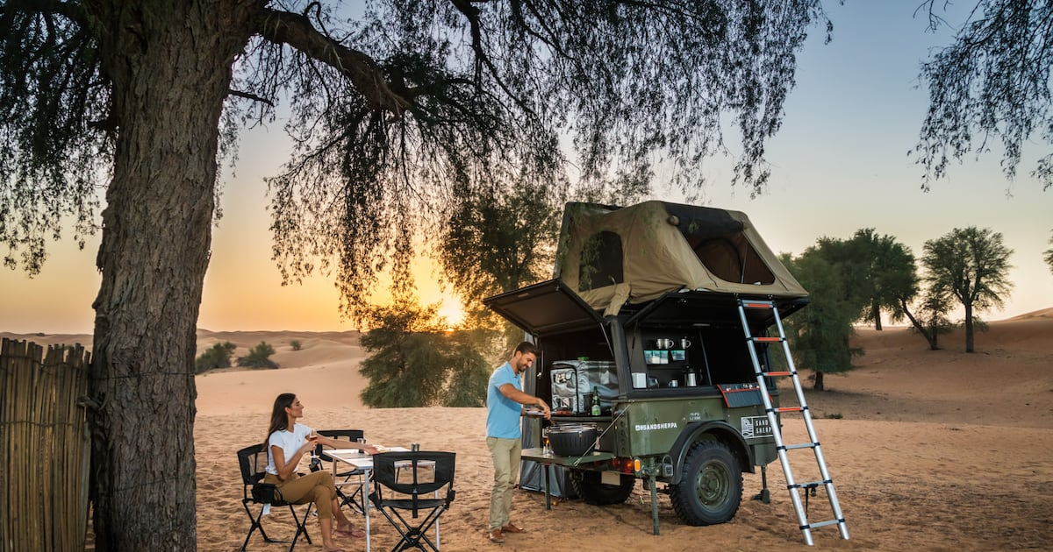
4
The beautiful Khor Fakkan coastline is perfect for:
Highlights:
- Easy parking for all campers
- Beachfront BBQ & seating
- Sunrise views 🌅

🏞️ 3. Al Rafisah Dam – Mountain Camping Experience
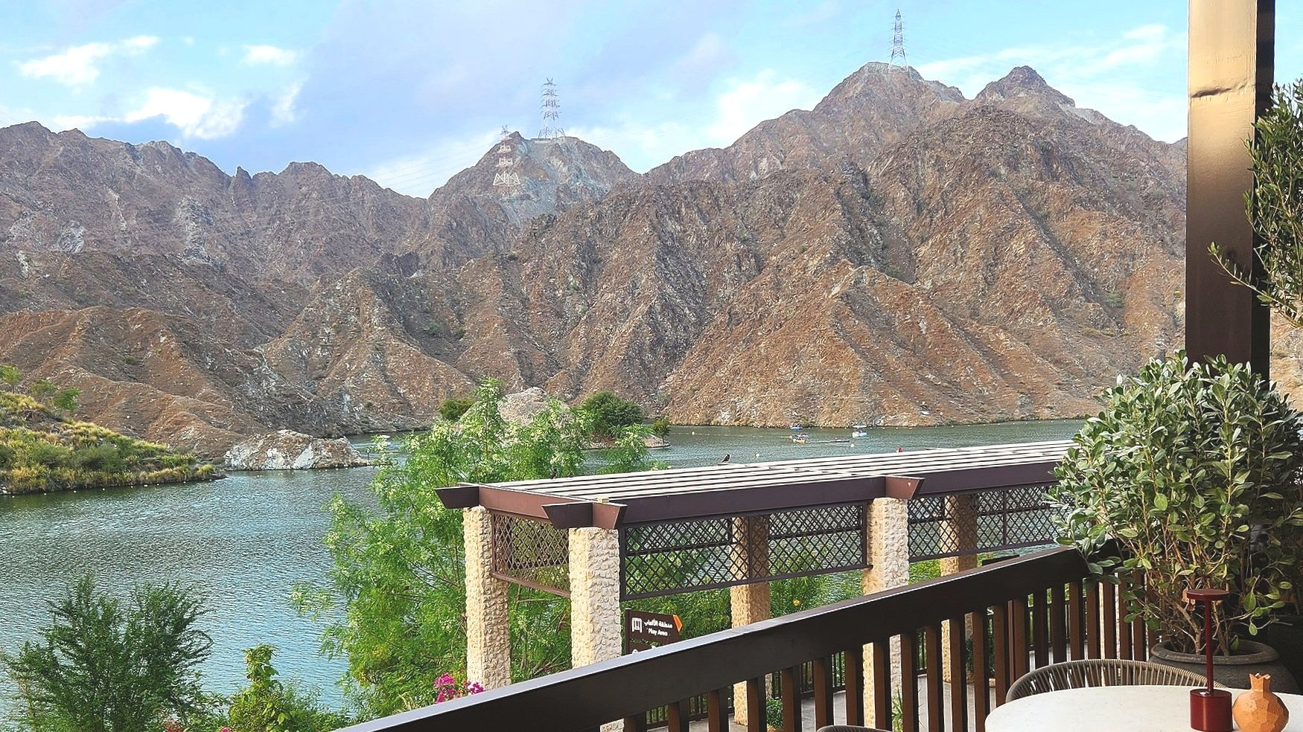
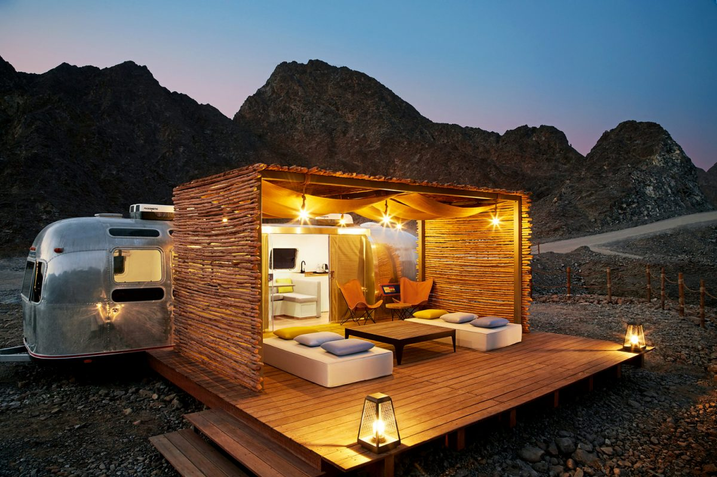
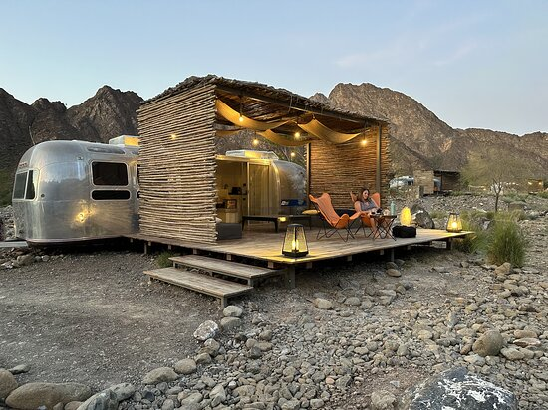
4
Camp near Al Rafisah Dam for a scenic escape.
Best for:
- Relaxed camping
- Family BBQ setups
- Cooler mountain weather

🏜️ 4. Fossil Rock – Adventure & Photography Camping
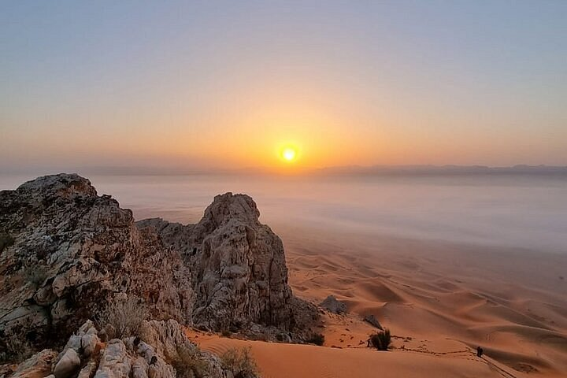

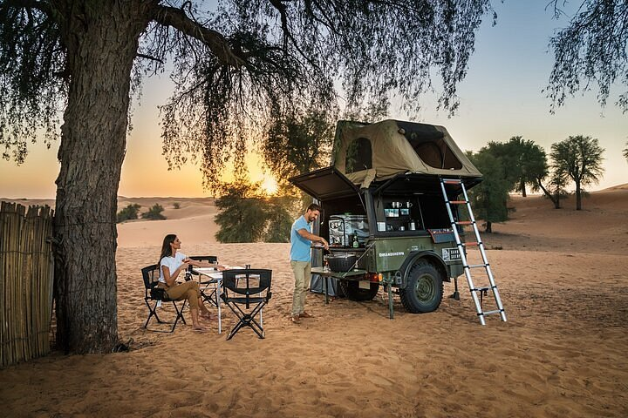
4
Near Mleiha, Fossil Rock offers:
- Stunning desert landscapes
- Ideal for Remal Caravan photo shoots
- Quiet premium camping setups

🏞️ 5. Wadi Shawka – Off-Road RAM Camper Paradise
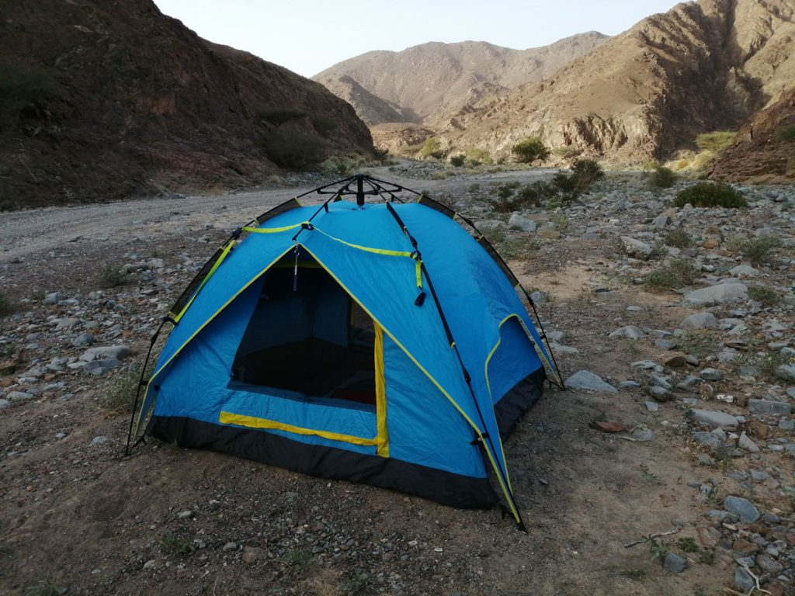
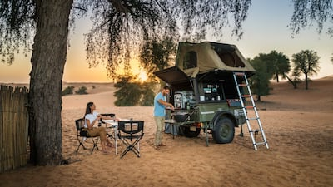
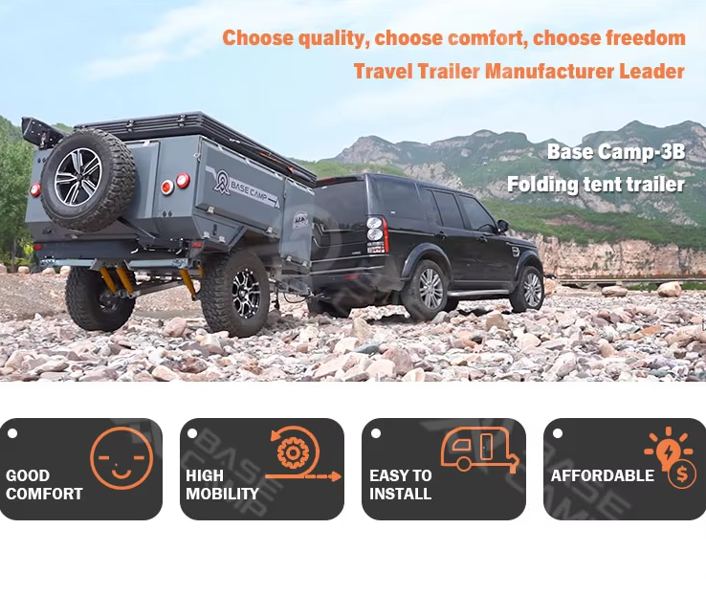
4
Wadi Shawka is perfect for:
Ideal vehicles:
- RAM popup campers 🛻
- 4x4 overland trucks
Experience:
- Off-road adventure
- Peaceful nature camping

🍖 Remal Caravan BBQ & Premium Setup Tips
- Use portable BBQ grill + prep table
- Add Remal Caravan branded lighting & flags
- Arrange luxury seating layout (Instagram-ready)
- Use warm LED lights for premium night vibe

🚐 Vehicle Guide (Remal Caravan Fleet Style)
- Iveco Motorhomes: Full comfort, best for beach & desert
- Camping Trailers: Family setups, easy access locations
- RAM Popup Campers: Off-road, flexible, adventure-ready

🌟 Final Thoughts
With Remal Caravan branding + RAM popup campers, Sharjah camping becomes more than a trip—it becomes a premium outdoor lifestyle experience. Whether you're in the dunes of Al Badayer or by the beaches of Khor Fakkan, you can create luxury camping setups that stand out.

👉 If you want next:
- I can edit YOUR actual vehicles with Remal Caravan branding into these locations
- Create Instagram ads, reels, or posters
- Design a full business brochure for Remal Caravan

Voice

Ajman Motorhome Camping
You’re viewing user-generated content that may be unverified or unsafe.
Report
🏕️ Sharjah Camping Sites for Motorhomes, Trailers & RAM Popup Campers
(Remal Caravan Edition 🚐✨)
Sharjah is a hidden gem for campers—offering desert dunes, beaches, and mountain escapes perfect for motorhomes, camping trailers, and RAM popup campers. With the right setup and Remal Caravan branding, your camping experience becomes both premium and adventure-ready.

🚐 Remal Caravan Camping Setup (Motorhomes, Trailers & RAM Popup)



4
🔥 Signature Setup by Remal Caravan:
- Branded Remal Caravan motorhomes & trailers
- RAM popup campers for off-road flexibility
- Outdoor BBQ station 🍖
- Premium chairs, tables & ambient lighting 💡
- Full desert/beach lifestyle setup
Perfect for marketing, rentals, and customer experiences.

🏜️ 1. Al Badayer Desert – Best for Full Setup Camping



4
At Al Badayer Desert, you can create a full Remal Caravan experience.
Ideal for:
- RAM popup campers 🛻
- Iveco motorhomes 🚐
- Camping trailers
Activities:
- BBQ nights & bonfire 🔥
- Dune bashing
- Group camping setups

🌊 2. Khor Fakkan Beach – Coastal Luxury Camping



4
The beautiful Khor Fakkan coastline is perfect for:
Highlights:
- Easy parking for all campers
- Beachfront BBQ & seating
- Sunrise views 🌅

🏞️ 3. Al Rafisah Dam – Mountain Camping Experience



4
Camp near Al Rafisah Dam for a scenic escape.
Best for:
- Relaxed camping
- Family BBQ setups
- Cooler mountain weather

🏜️ 4. Fossil Rock – Adventure & Photography Camping



4
Near Mleiha, Fossil Rock offers:
- Stunning desert landscapes
- Ideal for Remal Caravan photo shoots
- Quiet premium camping setups

🏞️ 5. Wadi Shawka – Off-Road RAM Camper Paradise



4
Wadi Shawka is perfect for:
Ideal vehicles:
- RAM popup campers 🛻
- 4x4 overland trucks
Experience:
- Off-road adventure
- Peaceful nature camping

🍖 Remal Caravan BBQ & Premium Setup Tips
- Use portable BBQ grill + prep table
- Add Remal Caravan branded lighting & flags
- Arrange luxury seating layout (Instagram-ready)
- Use warm LED lights for premium night vibe

🚐 Vehicle Guide (Remal Caravan Fleet Style)
- Iveco Motorhomes: Full comfort, best for beach & desert
- Camping Trailers: Family setups, easy access locations
- RAM Popup Campers: Off-road, flexible, adventure-ready

🌟 Final Thoughts
With Remal Caravan branding + RAM popup campers, Sharjah camping becomes more than a trip—it becomes a premium outdoor lifestyle experience. Whether you're in the dunes of Al Badayer or by the beaches of Khor Fakkan, you can create luxury camping setups that stand out.

👉 If you want next:
- I can edit YOUR actual vehicles with Remal Caravan branding into these locations
- Create Instagram ads, reels, or posters
- Design a full business brochure for Remal Caravan

